These directions will explain typical control installations only and will not cover any plow light applications. See website for full color installation manual
Warning you must unplug the power plug from the truck / equipment after each and wire in an on off switch (included) on the ground wire of the receiver. Failure to do this could result in accidental operation, battery drainage over a long period of time, serious injury or even death. Intended for off road use only.
Receiver / Solenoid Box Details All Plows See Fig 1
Truck side- Connect a 4 gauge power ground plug directly to the positive and ground of the battery and route it through the grill.
Plow Side connections. Connect a 4 gauge power ground plug (red) to one of the larger posts on the solenoid (this will become the always hot post). (Black) to the ground post on gray enclosure box
Connect a (black) 4 gauge wire with eyelets from ground post of plow motor to ground post on gray pvc enclosure box.
Connect a (red) 4 gauge wire with eyelets from positive post of plow motor to other large post of solenoid.
Connect a (black) 14 gauge 3” wire with eyelets from one of the small posts of the solenoid to the ground post on the gray pvc enclosure box.
Connect gray wire from wireless to other small post on solenoid.
Connect the black wire from the wireless to the ground post on the gray pvc enclosure.
Connect the red wire from the wireless to the hot side of the solenoid with a 10 amp fuse link.
When You have completed wiring the grey PVC box make sure to add a couple of drain holse on the bottom.
Lighting- There are numerous variations of how to control the equipment lighting based on equipment and vehicle type which is not covered in our manuals. The best way for the lights is to use an automotive relay (see instructions in this manual) and one of the extra on off functions of the wireless unit. Turn signals can be bypassed or wired with a quick disconnect if needed.
Transmitter Button Assignment details All Plows. See Fig 2
Button 1 label as (1) optional latching circuit to be used with automotive relay for lights… Yellow Wire
Button 2 label as (2) optional latching circuit to be used with automotive relay for lights… White Wire
Button 3 label as for angle left momentary with double pull on gray wire also operates Green and Purple Wires
Button 4 label as for angle right, momentary with double pull on gray wire for angle right…Blue Wire
Button 5 blank, Button 6 blank
Button 7 labeled for up momentary with double pull to gray wire for raise up…purple wire Button 8 labeled for down latching for float mode, up button will take it off float or press button (D) a second time to unlatch…. Yellow with black striped wire

Western and Fisher Straight blade controller wiring diagram. FIG 1

2way 3way 4way
Plow Side
VALVES
Truck Side
Battery

Use a 10 amp fuse link on the red receiver wire

Yellow with black tracer wire to 2 way valve, Purple wire to 4way valve, Green and Blue wires to 3 way valve.

Grey pvc box enclosure with plow solenoid.
Ground stud
Wireless Receiver- shown outside of grey pvc box for illustration.
FIG 2
Transmitter
2
1

VALVE WIRING
For Western and Fisher straight blade plows locate the 2w, 3w and 4w valves. SEE FIG 1
Connect the yellow with black tracer wire to the 2w valve coil.
Connect the green and blue wire to the 3w valve coil .
Connect the purple wire to the 4W valve coil
The black ground wire of the unit must me grounded to the valve coils also

NOTE: On newer Western Ultramount 2 straight blade plow systems on the plow side remove the module box and wiring as you will wire our unit direct to the valves.

For Boss Straight Blade Plows FIG 3
Connect Yellow with black tracer wire to SV3 lower valve coil
Connect Purple wire to SV2 raise valve coil
Connect Green and Blue wires to the S1 angle left coil

FIG 3
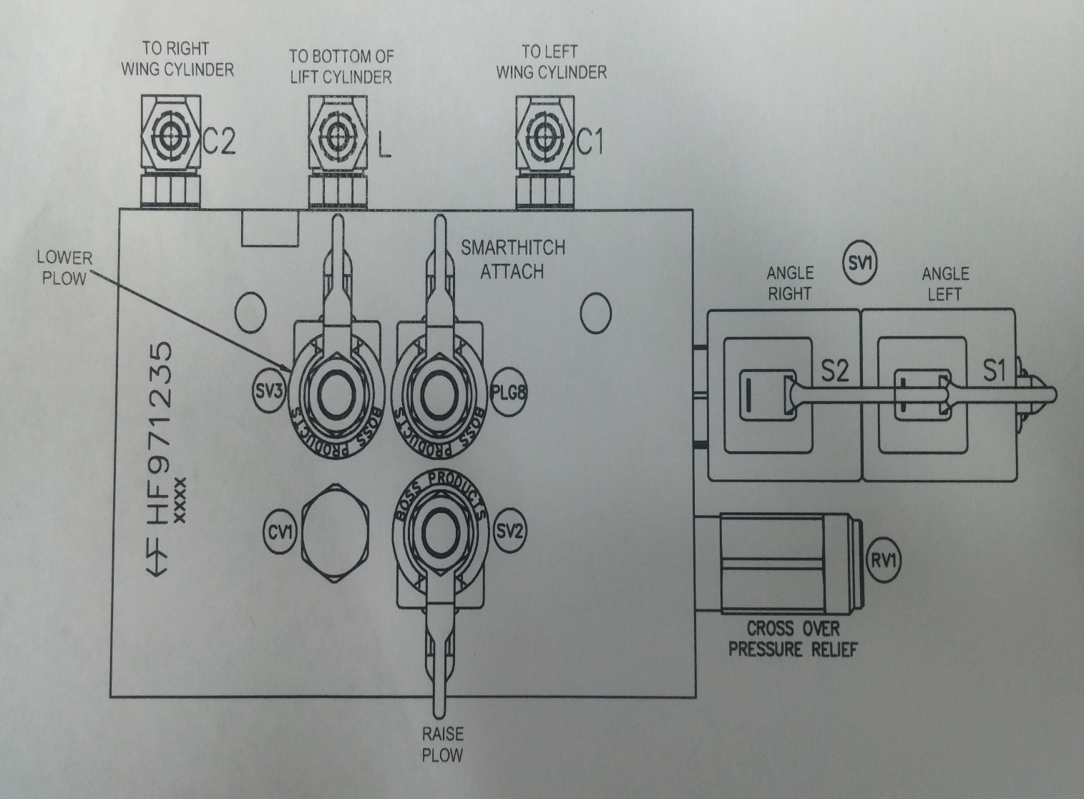

For Hiniker Straight Blade Plows FIG 4
Do not use purple wire tape and tuck
Connect Yellow with black tracer wire to S3 lower valve coil
Connect Green wire to the S1 angle left coil
Connect the Blue wire to the S2 angle right coil

FIG 4
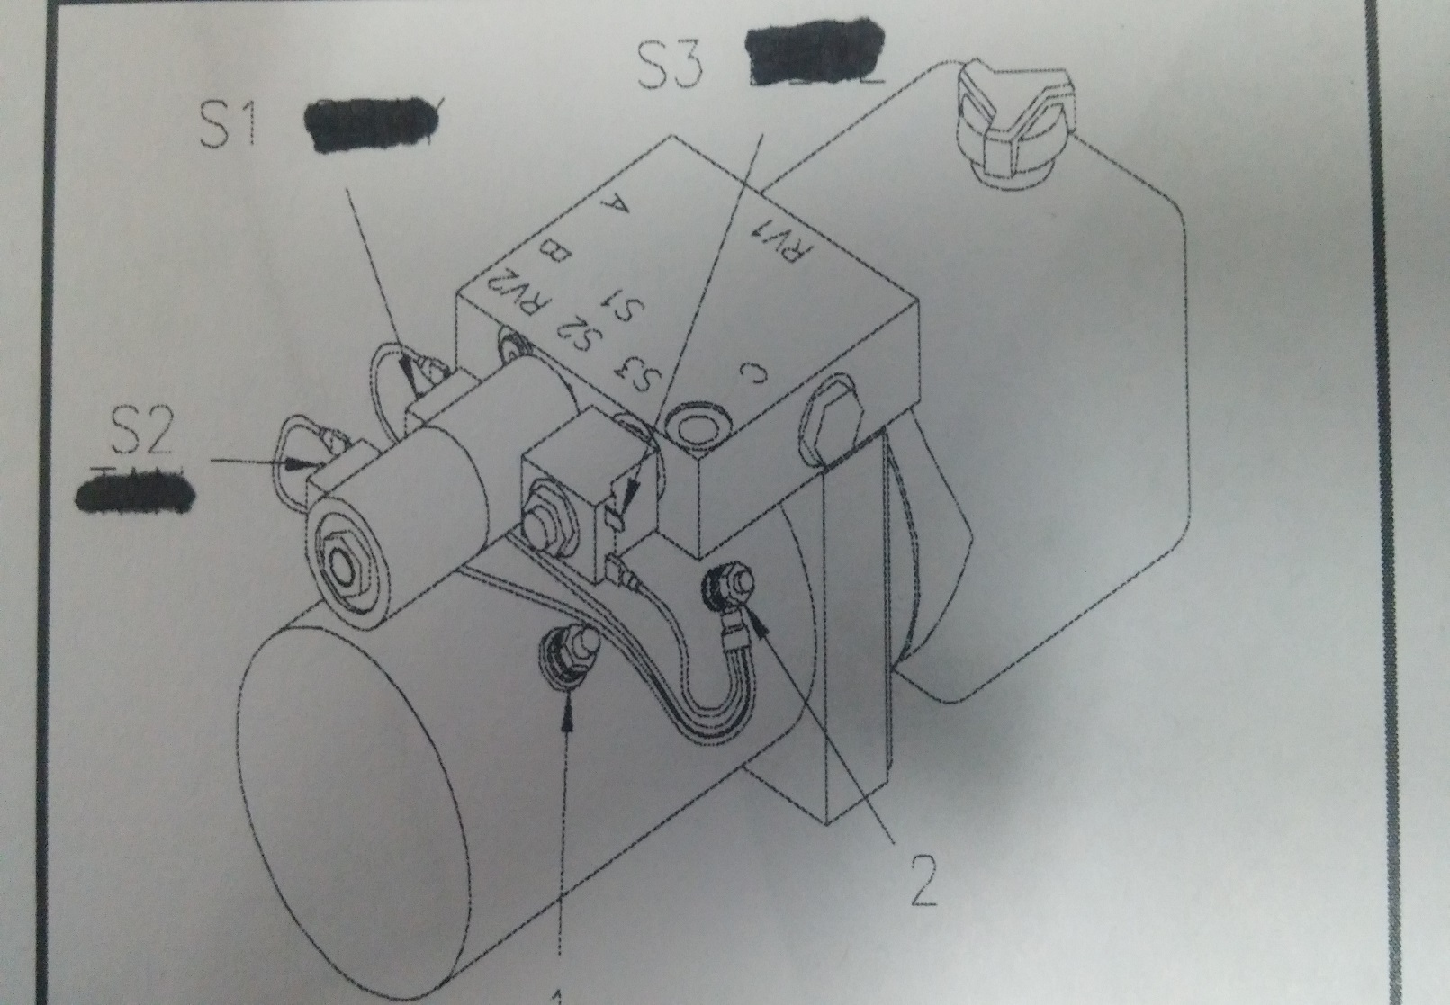

For Meyer E-46 and E-46H ONLY Straight Blade Plows FIG 5
Do not use purple wire tape and tuck
Connect Yellow with black tracer wire to A valve coil
Connect Green wire to the B angle left coil
Connect the Blue wire to the C angle right coil
For Meyer / Diamond E-47, E-47H, E57, E-60, E-60H ONLY Straight Blade Plows FIG 5
Do not use Blue Wire Tuck and Tape
Connect Purple wire to B valve coil
Connect Yellow with black tracer wire to A valve coil
Connect the Blue wire to the C angle right coil
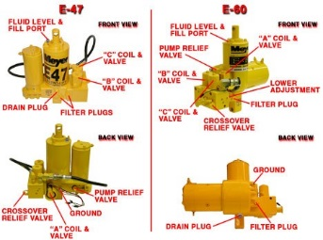

Blizzard Straight Blade Plows 680LT / 720LT
Connect Purple wire to S6 coil Raise
Connect Yellow with black tracer wire to S5 and S8 coil Lower
Connect Green Wire to S3 coil Angle Left
Connect Blue wire to S4 coil Angle Right

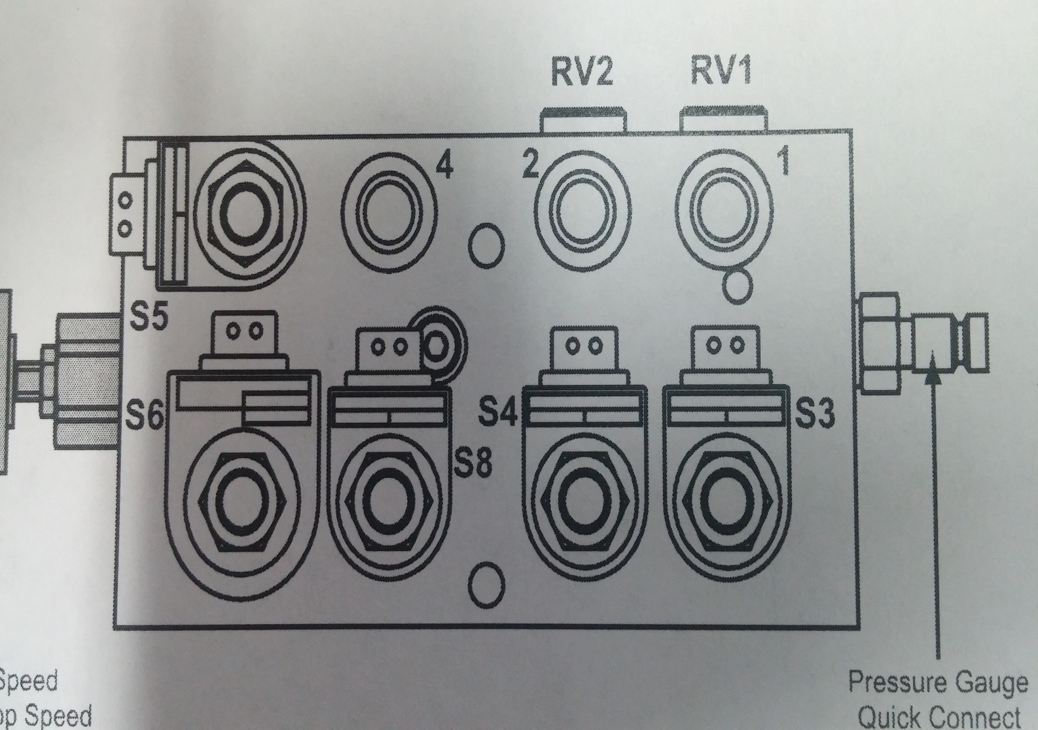

Blizzard Straight Blade Snow Plow 7600HD 8000HD 8600HD 9000HD
Connect Purple wire to S2C1 coil Raise
Connect Yellow with black tracer wire to S1 and S2C2 coil Lower
Connect Green Wire to S3C1 coil Angle Left
Connect Blue wire to S3C2 coil Angle Right
Leave power switch and Arm Blade operation switch intact.

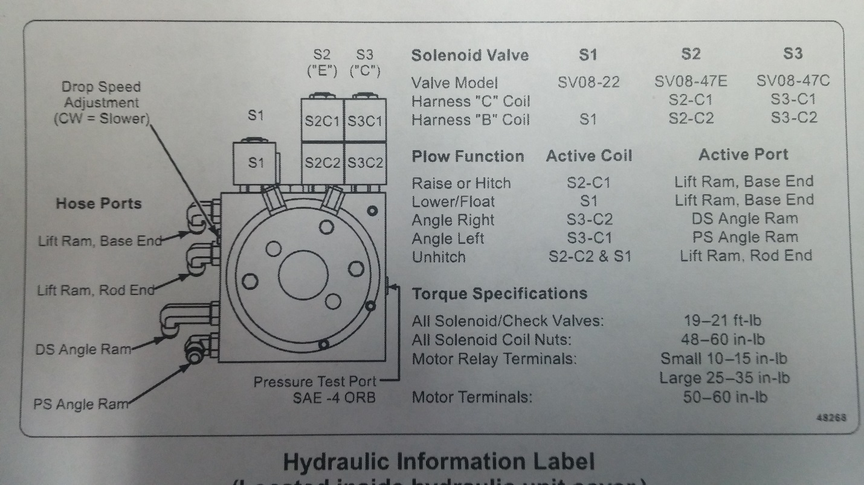

Snoway Straight blade plows Gravity down ( non down pressure plows)
Connect Yellow with black tracer wire to B lower valve coil
Connect Purple wire to C raise valve coil
Connect Green wire to the D angle left coil
Connect the Blue wire to the A angle right coil

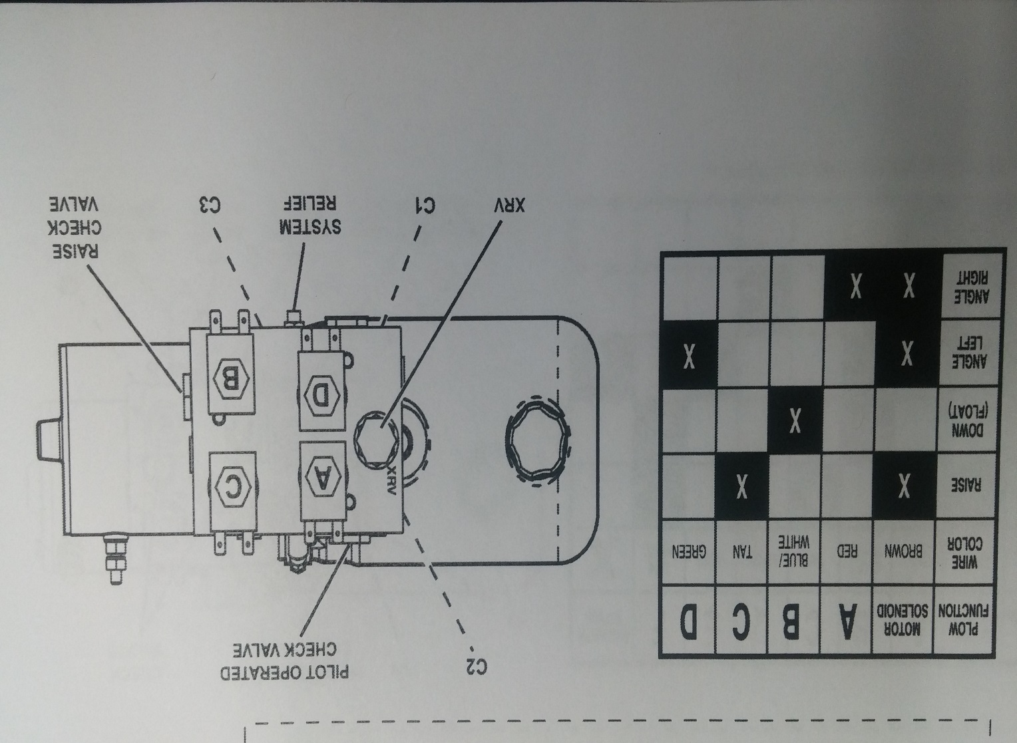

STRAIGHT BLADE SNOW PLOW CONTROL INCLUDES.
Wireless receiver with wire leads, weather proof enclosure and cover with screws.
Wireless transmitter with 3m glow in the dark label and raised button labeling.
Rubber boot and lanyard for transmitter

STRAIGHT BLADE SNOW PLOW KIT INCLUDES
(1) pvc enclosure box to mount on plow side
(1) sealed cover for pvc enclosure box
(1) snow plow solenoid
(1) wireless programmable receiver in sealed weather proof enclosure
(1) wireless transmitter with 3m raised button glow in the dark label and rubber protection boot and lanyard
(1) plow side power ground cable plug end
(1) truck side power ground cable plug end
(2) truck and plow side plug dust covers
(1) 24" #4 gauge black ground cable with eyelets (plow motor to enclosure)
(1) 24" #4 gauge red power cable with eyelets (plow motor to solenoid)
(1) short 14 gauge ground wire solenoid.
(4) 3m velcro strips to secure wireless inside enclosure
(1) Ground stud for enclosure box.
Misc hardware, cover screws, wiring connections
Complete instructions

Other Considerations and Disclaimer
Some straight blade plows are not covered in this manual as we cover most of the major brands. Use these directions as a guide for other brands.
DISCLAIMER- Not responsible for errors in this manual. There may be some variations of the common wiring connections from brand to brand. Intended for off road use only. As with any equipment safety guidelines should be followed at all times. Keep children, pets and all persons away from the equipment when operating. Disconnect the power when not using to prevent accidental operation. Protect all circuits with fuses to prevent shorts.
The trade names Boss, Western, Meyer, Blizzard, Diamond, Hiniker, Snoway and any others are mentioned for illustration purposes only. This product is not in any way authorized for use by these manufacturers as is any non oem part or accessory.
The end user assumes all liability in the proper installation and application of this product.

Programming Transmitter to Receiver:
The following are the step by step procedures for setting the unique address between the transmitter and receiver or adding extra transmitters to the receiver (up to 40transmitters).
Note you need to be next to the receiver and the receiver needs to have 12 volt power and ground connected and the cover off of it.
On the backside of the standard Transmitter, use a paperclip and GENTLY insert it in the hole next to the clear blue window. Once the programming button is depressed, a blue LED will begin to blink for 15 seconds. Flip the Transmitter over and firmly depress all 8 buttons starting with the ON button within 15 seconds. Now the Transmitter has acquired a 1 in 16 million address. MAKE SURE THE BLUE LIGHT GOES OUT BEFORE PROCEEDING.
Next step is to remove the receiver box cover noting the drain hole positions in the cover. With the receiver connected to a 12VDC power source look inside the box next to the red LED depress the black programming button. The red LED will begin to flash for 15 seconds. Take the Transmitter while the red LED is flashing and depress all buttons one at a time on the transmitter. When you are finished press the black button on the receiver again and the red light will stop blinking and you are now programmed. To test this press a button on your transmitter and the red light on the receiver will come on. Re-install the cover noting drain hole position, depress the “OFF” button on the transmitter to make sure the unit is off. .
The 625is now ready to operate the DC motor.

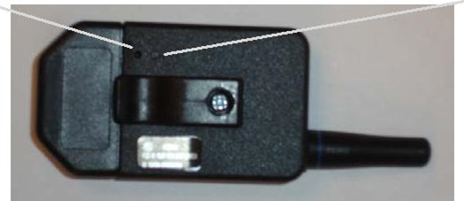
Blue light
Add button

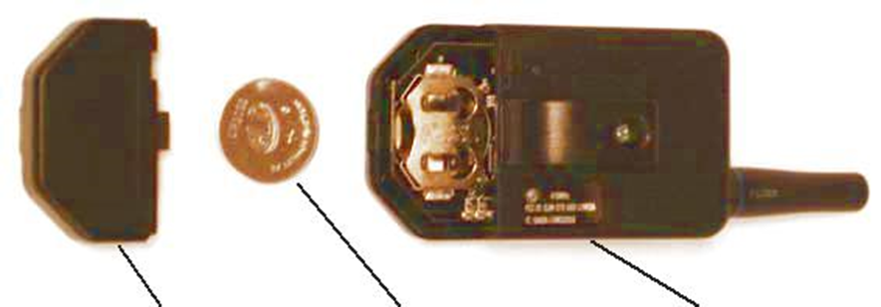
TRANSMITTER
2032 battery
COVER

12 volt automotive relay installation instructions. For lighting and other devices
When hooking up external devices like vibrators, and any items that require more power than the wireless unit allows you must use automotive 40/60 relays and follow the diagram below.

A relay is basically a switching device. The difference is that it can handle more amperage that a typical switch allowing a typical switching device to power high amperage devices.

- 12 volt power from battery connects to pin 30
- Battery ground connects to pin 85
- Power in from from activation switch or remote connects to pin 86
- Pin 87 connects to device that needs to be operated. Example valve, motor, lights….

Note wire that connects to pin 30 must be as large or larger that the device you need to operate that’s connected to pin 87

You should fuse or diode protect pin 85 and 87 to prevent back feed.

87a will have power when the unit is idle. This pin is not typically used in applications.

85
87A
87
30
86

