625DC MANUAL WITH VIBARATOR OPTION

625DC1 typical use is for a SINGLE MOTOR SALT SPREADER WITH VIBRATOR CONTROL.
NOTE TRANSMITTER NEEDS TO BE PROGRAMMED TO THE RECEIVER SEE PAGE 4 FOR PROGRAMING INSTRUCTIONS AND TROUBLESHOOTING.
For use with 12-volt DC only

625DC1 Wireless Variable Speed DC Motor Controller
How it Works:
The 625DC1 Wireless DC Motor Controller provides RPM control for a single, 2 pole DC motor that can output up to over 100 amps for up to 1 seconds and a continuous amperage of up to 75 amps. The speed or RPM control is done by providing the user 3 outputs, approximately 1/3 increments of the maximum motor RPM. The 625DC1 also incorporates a on off vibrator function or can be used for a light etc.…
To protect the motor and electronics, the 625DC1 has built-in safety circuits. These include:
- Automatic shut down if motor is locked up. How this is done is if the receiver senses a current draw of more than 100 amps at start up for more than approximately 1000mS, the unit will shut down from 1 to 30 seconds.
- Automatic shut off if the current draw does not drop below 75 amps after 6 to 8 seconds. Once again, the receiver will shut down for 1 to 30 seconds.

Typical Wiring Connection Diagram
MOTOR A 12VDC
Spinner Motor
PWM OUT (GREEN WIRE)
HIGH AMP
Spinner Motor
PWM OUT
(YELLOW
WIRE)
LOW AMP
Vibrator Motor
625DC1 RECEIVER

12VDC GROUND FROM REGULATED SOURCE

12VDC GROUND (BLACK WIRE)
MOTOR B
12VDC
Vibrator Motor
12VDC POWER FROM REGULATED SOURCE (RED WIRE) should be 4-gauge wire min.

625DC MANUAL WITH VIBARATOR OPTION

We highly recommend the use of Alumiconn #18 - #10 awg connectors only. Available at snowplowsplus.com or controlallwireless.com

Do not use the 7 prong plug on your truck as power and ground for this unit. You need to run a minimum of 6-gauge wire (power and ground) directly from your battery to the unit.

Connect the red wire from the receiver to the power source and to 1 post on the vibrator motor.

Connect the black wire from the receiver to the ground source and to 1 post on the spinner motor.

Connect the yellow wire from the receiver to the open post on the vibrator

Connect the green wire from the receiver to the open post on the spinner motor.

Transmitter operation- Note button 8 is a on off single button for the spinner only.

***User must maintain good, clean connections for proper operation and to avoid damage to the receiver and void the warranty***

Note: certain non FCC approved accessories and LED lighting may cause interference with wireless units.

Make sure your spinner/augers turn freely before attempting operation

Programming Transmitter to Receiver:
The following are the step by step procedures for setting the unique address between the transmitter and receiver or adding extra transmitters to the receiver (up to 40 transmitters).

Video link

- On the backside of the Transmitter, use a paperclip and insert it in the hole next to the clear blue window. Once the programming button is depressed, a blue LED will begin to blink for 15 seconds. Flip the Transmitter over and firmly depress all 8 buttons starting with the ON button within 15 seconds. Now the Transmitter has acquired a 1 in 16 million address. WAIT UNTIL THE BLUE LIGHT STOPS BLINKING BEFORE YOU CONTINUE.
- Next step is to remove the receiver box cover noting the drain hole positions in the cover. Hook up the Power (red wire) and Ground (black wire) to a 12VDC power source. Inside the box next to the red LED depress the black programming button. The red LED will begin to flash for 15 seconds. Take the Transmitter while the red LED is flashing and firmly depress the ON button within the 15 seconds. Now the unique address of the Transmitter will only be recognized by that matched receiver. The red LED will automatically shut off after 15 seconds. To make sure the programming procedure was successful, depress any of the Transmitter buttons and the red LED in the receiver should light. Re-install the cover noting drain hole position and re-connect the PWM (green wire) to the motor. The RF-600 is now ready to operate the DC motor.
READ*******************Troubleshooting.
DO NOT CHANGE YOUR TRANSMITTER BATTERY UNLESS YOU HAVE FOLLOWED PROPER TROUBLESHOOTING.see transmitter programming above. Always test your functions before loading your spreader so you can visually see and hear the different rpm functions. Make sure your discharge chutes are open and baffles adjusted to the material you are using.
Keep transmitter out of extreme cold or warm up before using.
To verify power to the receiver remove cover press the black button if it blinks red there is power to the unit.
Keep power/ ground connections clean and tight, use dielectric grease, seal backside of connections.
Always disconnect power and ground cable when not in use
***User must maintain good, clean connections for proper operation and to avoid damage to the receiver and void the warranty***

Note: certain non FCC approved accessories and LED lighting may cause interference with wireless units.

Make sure your spinner/augers turn freely before attempting operation

625DC MANUAL WITH VIBARATOR OPTION

OPERATION:

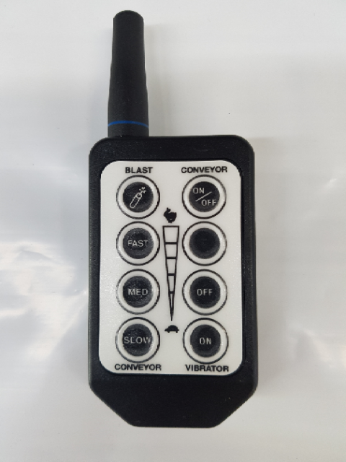

625DC1 blue ringed

TRANSMITTER not actual

Shown above is a typical transmitter for wireless operation of a 12VDC motor. The button functions are as follows:

ON VIBRATOR This button turns the vibrator on
OFF VIBRATOR This button turns the vibrator off
ON/OFF shuts down the spinner only
speed controls slow med fast and blast

**** It is recommended that when the DC motor/s is under high loads that the control first be started at medium to high speed for the first 1 to 5 seconds of operation to avoid damage to the motor or control and may void the warranty****

Optional on some applications for reference only

Relay to be used with higher amp latching circuits. Use a typical sealed 40/60 automotive relay available at most auto parts stores or from us.

A relay is basically a switching device. The difference is that it can handle more amperage that a typical switch allowing a typical switching device to power high amperage devices.

- 12-volt power from battery connects to pin 30
- Battery ground connects to pin 85
- Power in from from activation switch or remote connects to pin 86
- Pin 87 connects to device that needs to be operated. Example valve, motor, lights….

Note wire that connects to pin 30 must be as large or larger that the device you need to operate that’s connected to pin 87

You should fuse or diode protect pin 85 and 87 to prevent back feed.

87a will have power when the unit is idle. This pin is not typically used in applications.
85
87aA
30
86

87

